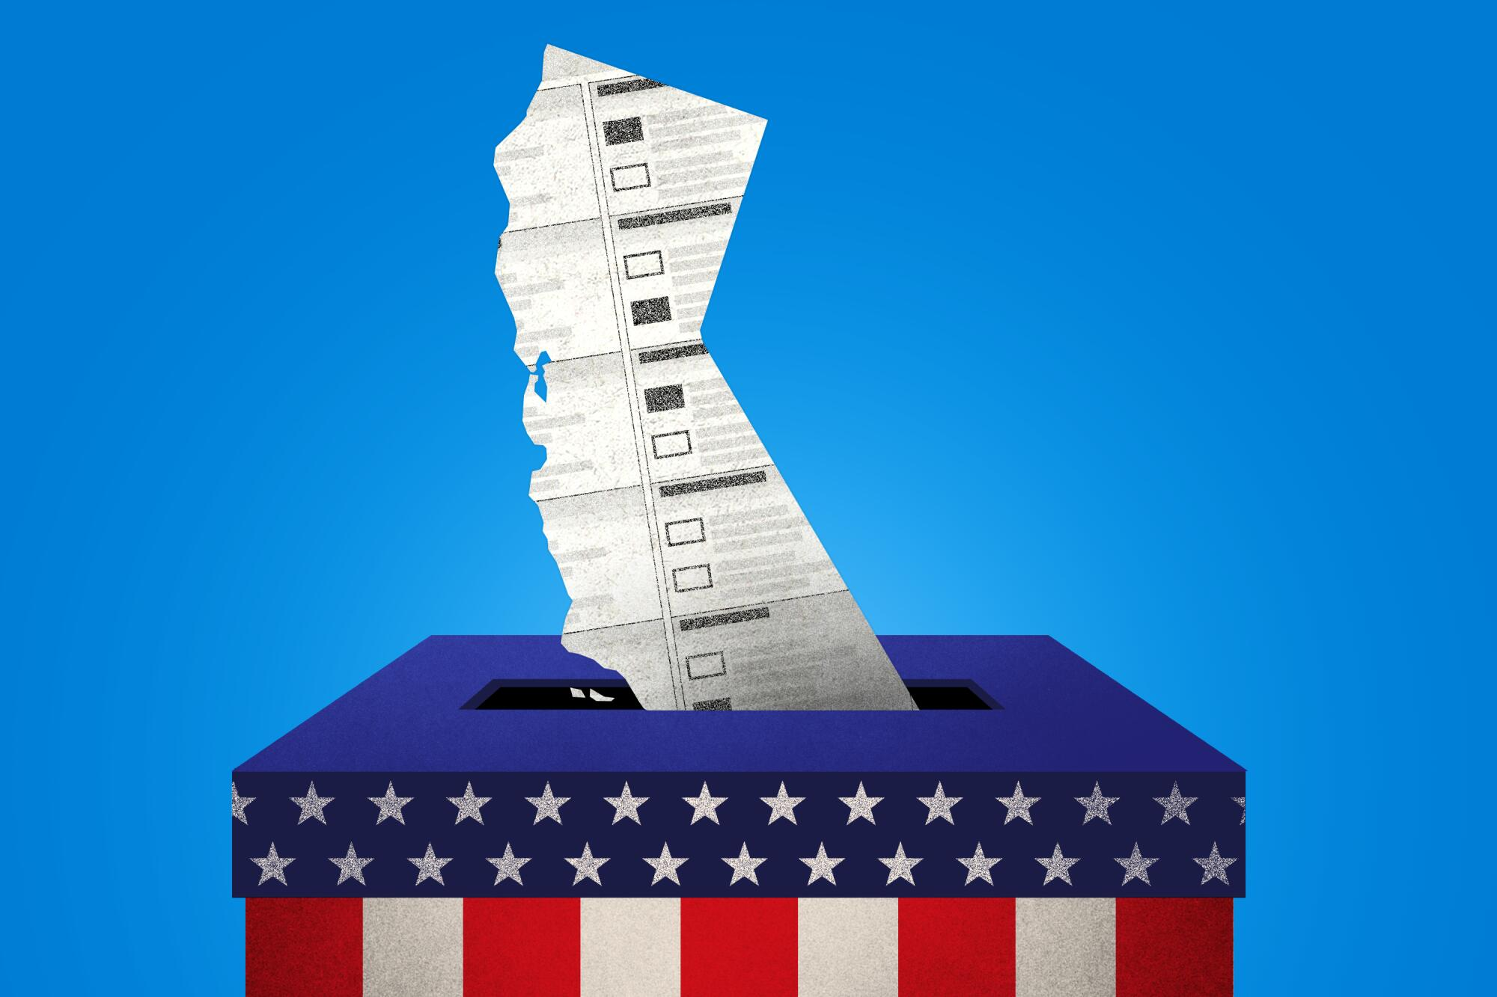
November 2024

Ballot Measures and Your City
- How the Bay Area Financing Housing Authority’s Measure (BAFHA) could help build affordable housing in your city?
- What are the impactions of the Taxpayer “Protection” Act be on your city?
- Hear from experts. Share what is happening in your city. Be part of the conversation.
  - A CALL TO ACTION for Peninsula Division Cities!!
Wednesday, May 22 11:30am – 1:00pm
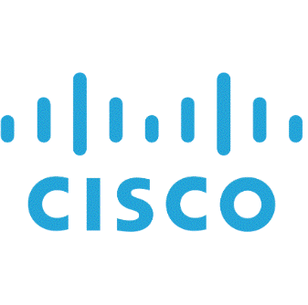
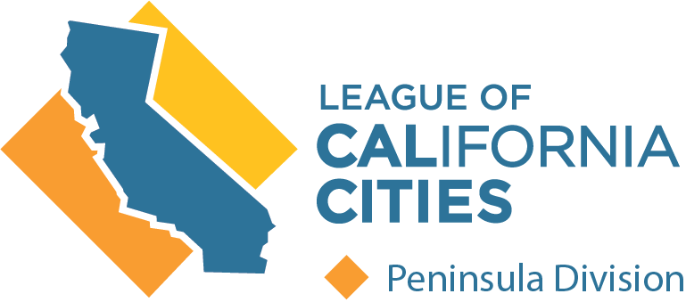
Cisco Systems Inc., 350 East Tasman Dr, San Jose. BUILDING #11

