SB 1: Road Repair and Accountability Act of 2017
SAMPLE Facebook or Nextdoor Posts and Tweets
It is important to communicate to your local residents about projects and benefits being made possible by SB 1.

We encourage you to notify your constituents and publicize any time you take an action related to an SB 1 project. Ideally, with each project/action, your city/county would issue a press release, post on Facebook, Nextdoor and tweet every time:
A new project goes out for bid
Construction starts on a new project
A project is completed
Routine and preventative maintenance such as overlays, seals, pothole filling, etc. take place
Annual project list is adopted
Your city/county is awarded a competitive transportation grant

We realize this is a lot of work, but it’s very important that your community members know that SB 1 is resulting in projects that will benefit them.

PLEASE INCLUDE PHOTOS IN ALL YOUR SOCIAL MEDIA POSTS! And please make sure to add the hashtags #SB1 and #RebuildingCA

Resources and Considerations for Social Posts:
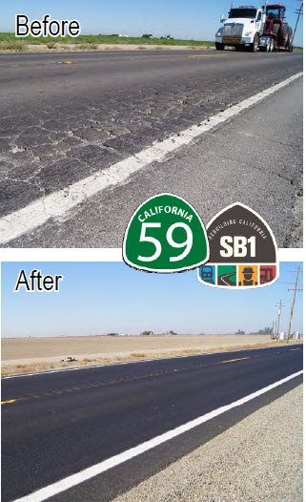
Before and after shots of bumpy to smooth roads/empty potholes then filled, etc. are very popular and easily show your followers the work being done by SB 1.
For a map of SB 1 transportation improvement projects across the state and in local communities visit www.RebuildingCA.ca.gov.
For a list showing how much SB 1 funding will flow to every city and county in CA, visit CSAC and the League’s SB 1 websites.
SB1 logo
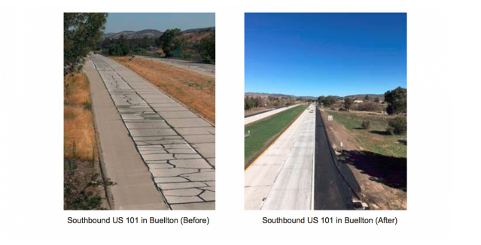

FACEBOOK OR NEXTDOOR
Specific to local projects:

Post 1
Name of City/County is ready to put #SB1 funding to work. Check out our list of local road improvement projects that will make it easier and safer to travel in our region. These projects are thanks to #SB1, the Road Repair and Accountability Act of 2017. #RebuildingCA
- Add pictures if possible

Post 2
Name of City/County is starting work on DESCRIBE PROJECT – what it is, construction timeframe, the difference it will make. This is the first/second/third project being funded through #SB1, the Road Improvement and Accountability Act. It will make it safer and easier to travel between X and X. #RebuildingCA
- Add pictures if possible

Post 3
Construction is beginning on PROJECT NAME/description. Traffic may be delayed for TIME FRAME but this project will make travel between X and X safer and easier. It’s the first/second/third/etc. of X number of projects the Name of City/County can start thanks to new transportation funding from #SB1, the Road Improvement and Accountability Act. #RebuildingCA
- Add pictures if possible

Post 4
Better roads coming soon to City/County thanks to #SB1. In the next 10 years, City/County will collectively receive $XX,XXX,XXX in funding to repair local streets and roads. View the local projects here! #RebuildingCA
- Link to: http://rebuildingca.ca.gov/map.html or CITY/COUNTY website/press release with this information)

Post 5
City/County will see $XXX MILLION in funds from #SB1 to help improve roads. Projects have already been identified. Check out how you will benefit here! #RebuildingCA
- Link to: http://rebuildingca.ca.gov/map.html or CITY/COUNTY website/press release with this information)

Post 6
#SB1 funds enable CITY/COUNTY to accomplish needed transportation improvement projects. Want to see what projects will be coming soon to our community? Check them out here!
- Link to: http://rebuildingca.ca.gov/map.html or CITY/COUNTY website/press release with this information)

Post 7
Thanks to new transportation funding from #SB1, the City/County of NAME will soon begin work on a number of important street/road repairs to make it safer and easier to travel in our area. #RebuildingCA
- LIST 3-5 large recognizable projects with tangible plain English descriptions
- Add pictures if possible

Post 8
Look for these #SB1 supported street/road projects to begin in MONTH #RebuildingCA:
- LIST 3-5 large recognizable projects with tangible plain English descriptions
- Add pictures if possible

Post 9
Local drivers may soon start noticing safer and smoother rides on City/County roads as #SB1 funding kick-starts local projects soon. #RebuildingCA Work will include LIST LOCAL PROJECT(S)
- Add pictures if possible

Post 10‬‬‬‬‬‬‬‬‬‬‬‬‬‬‬‬‬‬
#SB1 is helping City/County fix our roads, bridges & infrastructure including accessibility. This funding is essential for #RebuildingCA, keeping our roadways safe, decreasing congestion and creating jobs.
- Add pictures if possible

Post 11
#SB1 means $54 billion over the next decade to fix roads and freeways, ease traffic congestion, and seismically retrofit bridges in communities across California. Also will result in more dollars to transit. EVERY community benefits including City/County, check out our local projects here. #RebuildingCA
- Link to: http://rebuildingca.ca.gov/map.html or CITY/COUNTY website/press release with this information)
- Add pictures if possible

Post 12
For too long we’ve underinvested in our transportation infrastructure and #SB1 helps ensure Californians are driving on safe roads, instead of some of the country’s worst. #SB1 benefits EVERY community, including ours! #RebuildingCA
- Add pictures if possible

Post 13
Check out our before and after of PROJECT/STREET where we DESCRIBE PROJECT to make our local roads safer and smoother. #SB1 is #RebuildingCA
- Add pictures

TWITTER (now allows 280 characters)

Street/road repair projects funded through #SB1 coming soon to City/County #RebuildingCA. (add picture of key project)
- Link to: http://rebuildingca.ca.gov/map.html or CITY/COUNTY website/press release with this information)
- Add pictures if possible

New transportation funding will enable City/County to begin work on these street/road repairs. Here’s a list of approved projects. #RebuildingCA
- Link to: http://rebuildingca.ca.gov/map.html or CITY/COUNTY website/press release with this information)
- Add pictures if possible

City/County will use new transportation funding for X number of projects. Here’s a complete list upcoming street/road repairs. #RebuildingCA
- Link to: http://rebuildingca.ca.gov/map.html or CITY/COUNTY website/press release with this information)
- Add pictures if possible

Projects in CITY/COUNTY are already underway from #SB1! See where and what they are! #RebuildingCA
- Link to: http://rebuildingca.ca.gov/map.html or CITY/COUNTY website/press release with this information)
- Add pictures if possible

We are moving quickly to put #SB1 funds to work on repairing and rehabilitating local streets and roads. See local projects here.
- Link to: http://rebuildingca.ca.gov/map.html or CITY/COUNTY website/press release with this information)
- Add pictures if possible

Bad roads cost drivers every year. City/County will use $XX from #SB1 to make our roads safer and improve congestion. #RebuildingCA
- Link to: http://www.tripnet.org/docs/Urban_Roads_California_Statewide_TRIP_Release_11-01-2016.php

#SB1 is making PROJECT possible through accelerated funds. We are hard at work to make your roads smoother and safer. #RebuildingCA
- Add pictures if possible

#SB1 is bringing $XXX million to City/County for safer roads and highways. Every driver will benefit. #RebuildingCA
- Add pictures if possible

25% of CA bridges show significant deterioration & need to be repaired or replaced. #SB1 will help strengthen our roadways #RebuildingCA
- Add pictures if possible

Check out our before and after of PROJECT/STREET where we DESCRIBE PROJECT to make our local roads safer and smoother. #SB1 is #RebuildingCA
- Add pictures

